Sprint 1 - Endurance Design Document

March 23, 2023

### McKayla Miksza and Julia Buck

**Table of Contents**

**1.** **Executive Summary 3**

1.1 Project Overview 3

1.2 Purpose and Scope of this Specification 3

**2.** **Product/Service Description 3**

2.1 Product Context 3

2.2 User Characteristics 3

2.3 Assumptions 3

2.4 Constraints 3

2.5 Dependencies 4

**3.** **Requirements 4**

3.1 Functional Requirements 5

3.2 Security 5

*3.2.1* *Protection 5*

*3.2.2* *Authorization and Authentication 6*

3.3 Portability 6

**4.** **Requirements Confirmation/Stakeholder sign-off 6**

**5.** **System Design 6**

5.1 Algorithm 6

5.2 System Flow 6

5.3 Software 6

5.4 Hardware 6

5.5 Test Plan 7

5.6 Task List/Gantt Chart 7

5.7 Staffing Plan 7

# Executive Summary

## Project Overview

Project Sprint 1 - Endurance, is a project designed to allow the team members to create an application and later apply it to a robot that will allow it to follow the course set in advance. The intended audience of this project is Professor Eckert and class.

## Purpose and Scope of this Specification

The primary objective of this project is to utilize a particular software to develop a highly functional application. This application will subsequently be integrated with a specific hardware system, which will facilitate a demonstration of its capabilities.

**In scope**

* The given robot must complete the course outlined
* Completeion must include the avoidance of any objects that may be present
* The LED colors of the robot must change
* The lines must be soken at the beginning and the end of the course

**Out of Scope**

* The robot is able to stay at the center of each line segment of the course
* The robot can stop at the center of each corner
* The robot can turn 90 degrees at each turn to prepare the next line segment

# Product/Service Description

The general factors that will affect the product and it’s requirements would be the accessibility that we have as in the software given to us as well as the capabilities of the robot. Certain requirements are specified later than others because they can’t operate without something else happening they are all dependable on one another.

## Product Context

This product interfaces with a variety of systems like it because in order to succeed at the job it needs to do it has to connect with the robot which is a system in itself.

## User Characteristics

Julia Buck: Beginner with this type of system and product; Software engineering major

McKayla: Has a lot of prior knowledge, beginner with this system and product; Math Major

Dr. Eckert: Professional

## Assumptions

Assumptions that would possibly affect our requirements would be the availability of the testing room because in order to make sure the requirements are ran accurately we need access to our track. Another assumption that would affect our requirments would be accessibility to the sphero app because that is what connects and controls our entire robot. If the app was not available to us or crashed our robot instructions would have to change accordingly to fit into another apps system.

## Constraints

The things that will constrain the design options would be the lay out of the room/track and where furniture or walls in the room are placed because obviously those areas have to be avoided.

## Dependencies

The robot needs to be turned on, charged as well as connected for any of the requirements to function. In order for requirement 4 to work requirement 3 had to have the correct length and speed.

# Requirements

For this project to be functional and efficient the requirements must be discussed and layed out in a proper way.

According to the prompt the objective of the robot application is to travel the taped outline set in advance around the floor of Howard Hall room 208.

**PRIORITY 1 (“MUST HAVE”) REQUIREMENTS:**

1. There should be no issue of obstacles preventing the robot from completing this task.
2. The initial point will be in the yellow tile in the corner of the room, designated by the tape.
3. The LED light in the robot should turn green before commencing the rest of the application, as well as speak the line provided in the prompt.
4. The robot shall then proceed to complete the course, consisting of several points and straight pathways of different lengths.
5. At the completion of the course, the LED light in the robot should turn red and speak the line provided in the prompt.
6. Each team member should participate in the totality of the project, however, are allowed to split responsibilities to produce a better final product.

**PRIORITY 2 REQUIREMENTS:**

1. The blocks included in the code to roll the robot should include proportionate speed and timing to the course outline.
2. Between each of the rolls along the outline the robot should delay to allow the system to process the following commands.

**PRIORITY 3 (“NICE TO HAVE”) REQUIREMENTS:**

1. The block code is able to be precise in the rolls of the robot
   1. Never stray from each line segment of the course
   2. Stop directly at the intersection between tape segments
   3. Stop directly at the intersection when complete with the course
   4. Turn in the initial direction when the application completes the course entirely.

## Functional Requirements

| **Req#** | **Requirement** | **Comments** | **Priority** | **Date Rvwd** | **SME Reviewed / Approved** |
| --- | --- | --- | --- | --- | --- |
| ENDUR_01 | Start with the green light | Discussed and approved together | High | 03/02/23 | Approved |
| ENDUR_02 | Speak “Ready Set Go” at start | Agreed and approved | High | 03/02/23 | Approved |
| ENDUR_03 | Travel to each of the corner of the outline | Approved and discussed | High | 03/02/23 | Approved |
| ENDUR_04 | Turn right at each of the corner of the outline | Discussed | High | 03/02/23 | Approved |
| ENDUR_05 | Return to the starting location | Approved | High | 03/02/23 | Approved |
| ENDUR_06 | Not collide with any objects | Agreed and discussed how we will prevent this | High | 03/02/23 | Approved |
| ENDUR_07 | Stop with a red light | Approved together | High | 03/02/23 | Approved |
| ENDUR_08 | Speak “I’m done, and I need water” at end | Agreed together | High | 03/02/23 | Approved |

## Security

### Protection

The factors that will protect the system are encryption because only people who have access to Sphero will understand the code used for this project as well as the true meaning behind each action. Another thing that will help protect the system is activity logging because it will help us to identify patterns as well as be able to detect what is wrong and what is not. With activity logging we can access exactly where we began or left off in case we need to work backwards to see what may be causing issues. Lastly, our system is being protected by data integrity checks because as we move along with our project we are actively testing and trying out our code and making sure the robot is doing correctly what it should be doing. It’s helping us make sure our system is working accurately and completing its job.

### Authorization and Authentication

The factors would be that in order to begin the process a robot is needed to connect.

## Portability

The portability of our project is pretty dependable because it’s accessible on both McKayla and I’s computers as well as easy to access and report the coding that was done within the system to other data bases. For example it’s easy to screenshot the coding we have done and attach it to our github as well as a link. From there we attached it to ecampus which is another system.

# Requirements Confirmation/Stakeholder sign-off

| **Meeting Date** | **Attendees (name and role)** | **Comments** |
| --- | --- | --- |
| 03/02/2023 | Julia Buck, McKayla Miksza | Confirmed all |

# System Design

This section will provide all details concerning the technical design, staffing, coding, and testing the system.

## Algorithm

1. Set main LED to green
2. Speak “Ready Set Go”
3. Roll forward straight at a 0-degree angle for approximately 10 seconds
4. Roll forward straight at a 90-degree angle for approximately 5 seconds
5. Roll backward straight at a 0-degree angle for approximately 10 seconds
6. Roll backward straight at a 90-degree angle for approximately 5 seconds
7. Set main LED to Red
8. Speak “I’m Done and I Need Water”

## System Flow

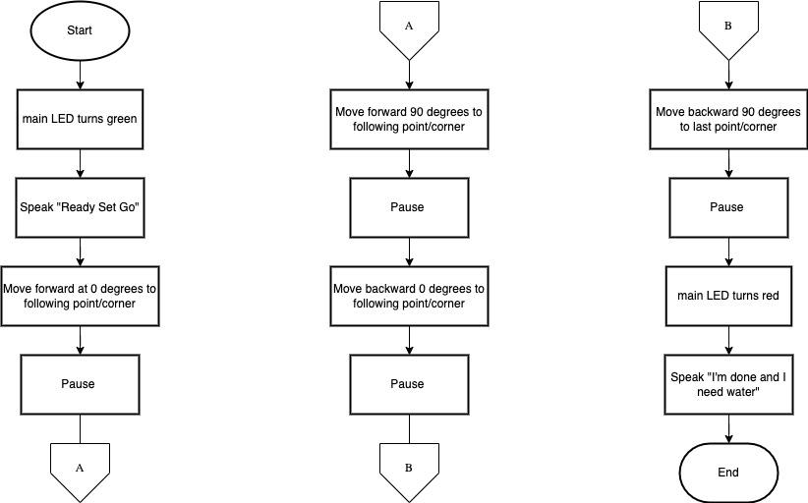

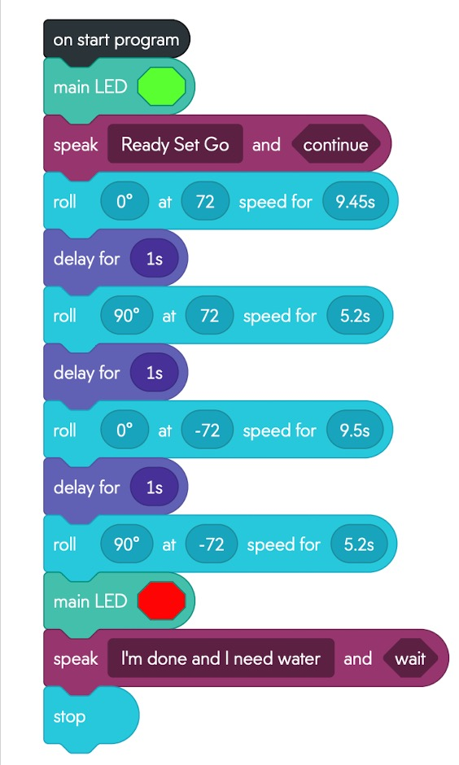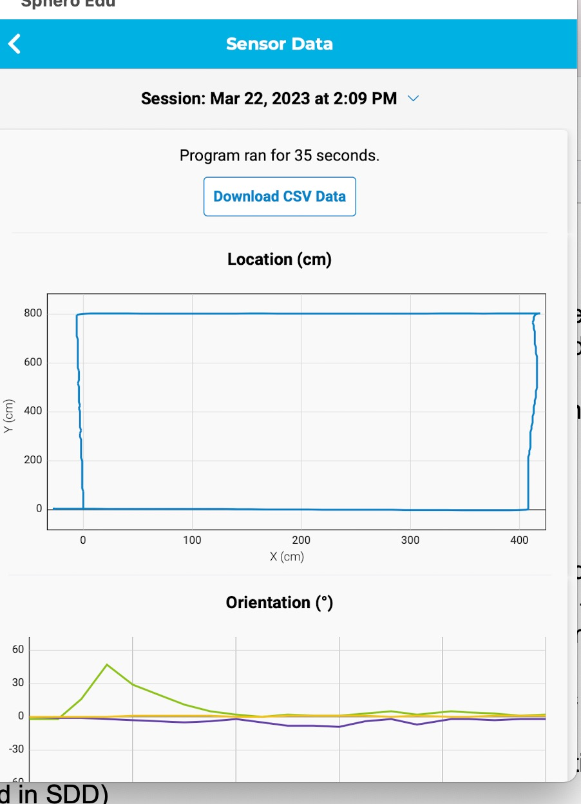

## Software

This application was developed and tested on Sphero Edu, using block code to deploy the application.

## Hardware

To develop, test, and demonstrate this application, the team members used different hardware platforms. These included 2 MacBook Laptops (one from each team member), which helped in the development of the application on the software Sphero Edu; the Sphero SPRK Coding Robot, which was used to test and demonstrate this application on the course outlined on the floor; the charger of the Sphero SPRK Coding Robot, which helped keep the robot powered for the testing process as well as the demonstration.

## Test Plan

| **Reason for Test Case** | **Test Date** | **Expected Output** | **Observed Output** | **Staff Name** | **Pass/Fail** |
| --- | --- | --- | --- | --- | --- |
| Requirement Number(s): ENDUR_01 | 03-22-23 | LED turns green at start |  | Julia Buck | PASS |
| Requirement Number(s): ENDUR_02 | 03-22-23 | Speaks “Ready Set Go” |  | McKayla Miksza | PASS |
| Requirement Number(s): ENDUR_03, ENDUR_05 | 03-22-23 | Moves straight from the initial yellow tile for first corner | Strayed from path and used the wall for support | Julia Buck | FAIL |
| Requirement Number(s):  ENDUR_03 | 03-22-23 | Moves straight from the initial yellow tile for first corner | Stayed on path and stopped at second point | Julia Buck | PASS |
| Requirement Number(s): ENDUR_04 | 03-22-23 | Turns 90 degrees |  | Julia Buck | PASS |
| Requirement Number(s): ENDUR_03 | 03-22-23 | Moves straight from the second point to third | Stayed on the line but moved too far from the point to count as successful | McKayla Miksza | FAIL |
| Requirement Number(s): ENDUR_03 | 03-22-23 | Moves straight from the second point to third | Stayed on the line and stopped at third point | McKayla Miksza | PASS |
| Requirement Number(s): ENDUR_04 | 03-22-23 | Turns 90 degrees |  | McKayla Miksza | PASS |
| Requirement Number(s): ENDUR_03, ENDUR_05 | 03-22-23 | Moves straight from the third point to fourth | Robot strayed from line and was unable to avoid obstacles such as chairs | Julia Buck | FAIL |
| Requirement Number(s): ENDUR_03, ENDUR_05 | 03-22-23 | Moves straight from the third point to fourth | Robot was able to avoid obstacles but still strayed from the line | Julia Buck | FAIL |
| Requirement Number(s): ENDUR_03, ENDUR_05 | 03-23-23 | Moves straight from the third point to fourth | Stayed straight and avoided all obstacles | Julia Buck | PASS |
| Requirement Number(s): ENDUR_04 | 03-22-23 | Turns 90 degrees |  | Julia Buck | PASS |
| Requirement Number(s): ENDUR_03, ENDUR_06 | 03-22-23 | Moves straight from fourth point and returns to original yellow tile | Stayed on line and stopped at the final/initial point | McKayla Miksza | PASS |
| Requirement Number(s): ENDUR_07 | 03-22-23 | LED turns red at end |  | Julia Buck | PASS |
| Requirement Number(s): ENDUR_08 | 03-22-23 | Speaks “I’m done, I need some water” |  | McKayla Miksza | PASS |

## Task List/Gantt Chart

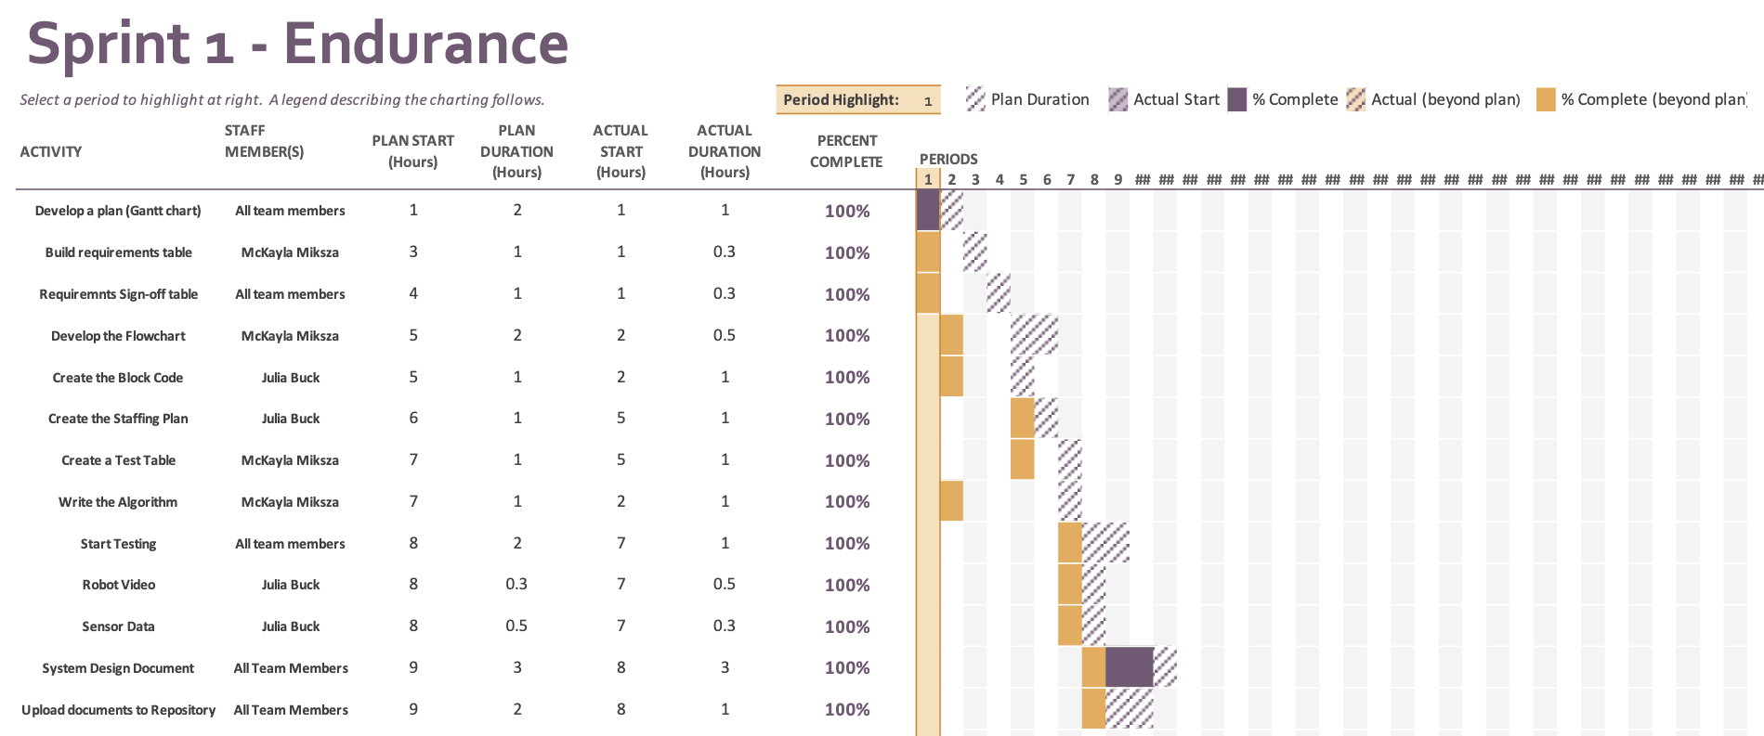

## Staffing Plan

| Name | Role | Responsibility | Reports To |
| --- | --- | --- | --- |
| McKayla Miksza | Team Member | Develop a Plan (Gantt Chart)  Build a Requirements Table  Requirements Sign-off Table.  Build a Flowchart  Create a Test Table  Create the Algorithm  Testing Process  System Design Document  Upload documents to Repository | Julia Buck |
| Julia Buck | Team Member | Develop a Plan (Gantt Chart)  Requirements Sing-off Table.  Create the Block Code  Create the Staffing Plan  Testing Process  Take Robot Course Completion Video  Take Screenshot of Sensor Data  System Design Document  Upload Documents/Video to Repository | McKayla Miksza |